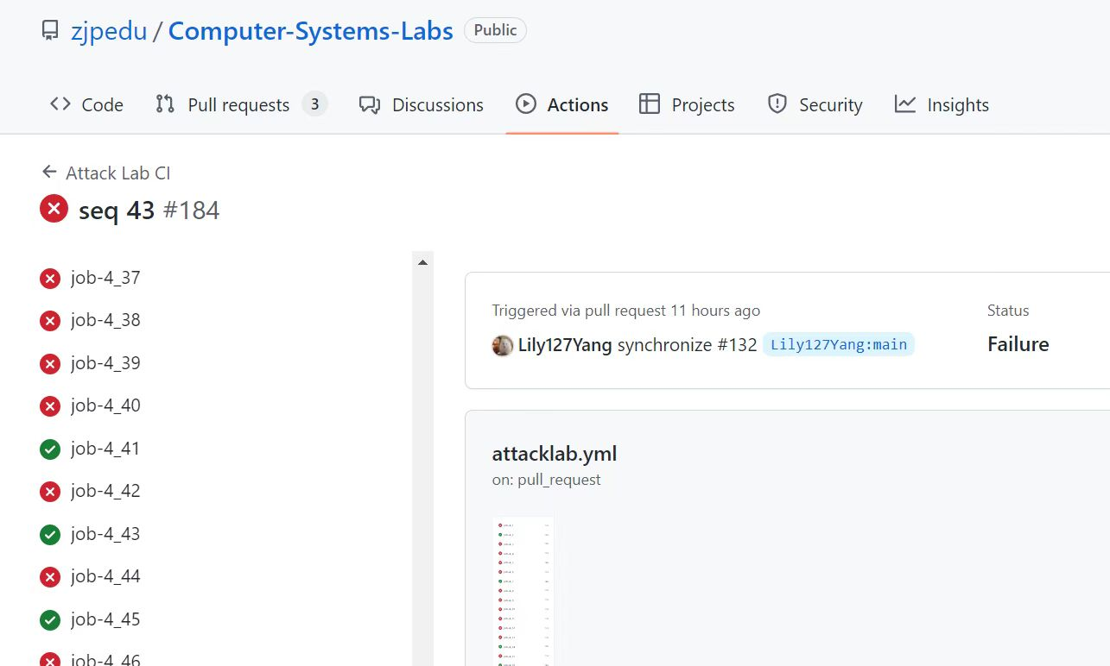

**Touch1**

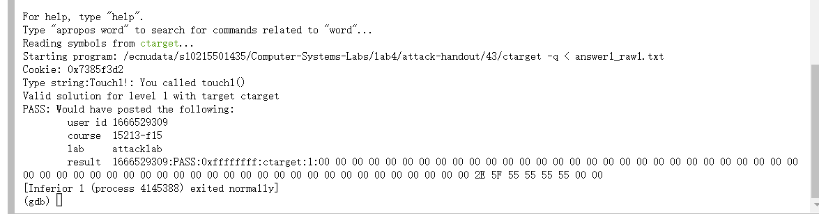

**Touch2**

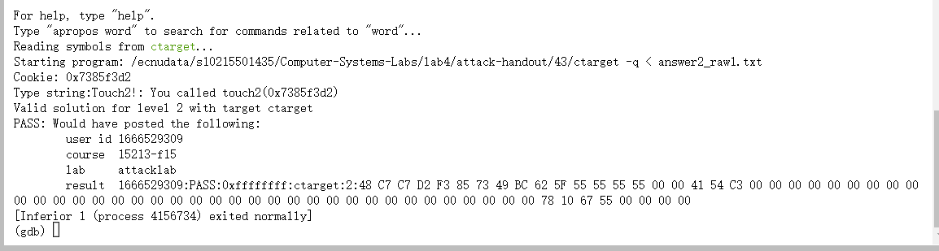

**Touch3**

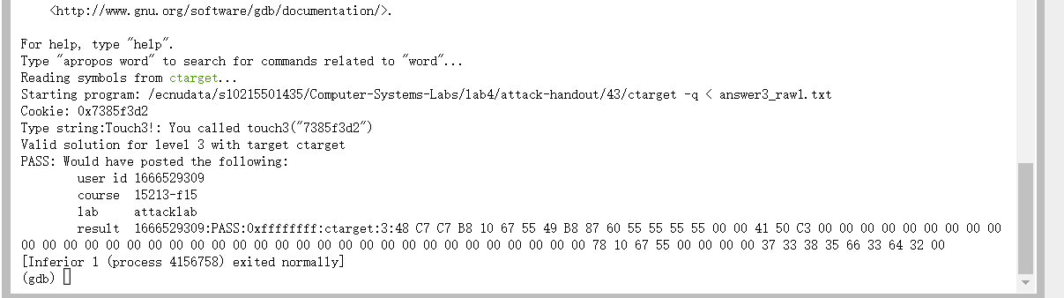

**Touch4**

